**Oyster Task Force Meeting Minutes**

**Wednesday, August 28, 2024, 10:00am**

**New Orleans Lakefront Airport**

**6001 Stars and Stripes Blvd.**

**New Orleans, LA**

**I.** Pledge of Allegiance

**II.** Roll call and introduction of guests

**Voting Members Present:**

Jakov Jurisic

Mitch Jurisich

Brad Robin

Brandt Lafrance

Al Sunseri

Matthew Slavich

Peter Vujnovich

**Voting Members Absent:**

Shane Bagala

Tracy Collins

Dan Coulon

Brandon Debarge

Sam Slavich

Willie Daisy

Steve Pollock

**Non-Voting Members Present:**

Robert Caballero

**Non-Voting Members Absent:**

Kyle Balkum

Davis Madere

Brian Lezina

**III.** Brad Robin motioned to approve the July 23, 2024 meeting minutes, 2nd by Brandt Lafrance. Motion carries.

Brad Robin motioned to approve the August 28, 2024 meeting agenda, 2nd by Jakov Jurisic. Motion carries.

**IV.** Treasury Report

Remaining Fund Balance- $572,134

Remaining Budget Balance- $126,125

Peter Vujnovich motioned to approve the treasury report, 2nd by Brad Robin. Motion carries.

**V.** Committee Reports

A. Public Private Oyster Seed Grounds Committee- no report

B. Enforcement-

July 17- August 13

**Region 4** (Iberia)

Iberia

2-40:4A- Violate sanitation code (refrigeration)

**Seizures**

3 Sacks

**Region 5** (Calcasieu, Cameron, Vermillion)

Vermillion

1-40:4A- Violate sanitation code (refrigeration)

3-56:431A- Unlawfully take oysters from private lease (3 subjects)

1-56:424B- Failure to have written permission

1-56:430B (1)Harvest oysters from unmarked lease.

**Seizures**

29 Sacks

**Region 6**: (Terrebonne, Lafourche, Grand Isle)

None

**Region 8**: (Jefferson, Plaquemines, St. Bernard, Orleans)

St. Bernard

1-40:4 A – Violate Sanitation Code – (refrigeration) (log Book)

**Seizures:**

55 Sacks

C. Legislative Committee- no report

D. Legal Committee- no report

E. Research Committee- no report

F. Coastal Restoration- no report; discussed chair for committee; meeting on the mid-barataria, parish report by Friday; Al Sunseri requested that CPRA provide an update on projects current and future on a regular basis

G. Marketing Committee- Anna Koehl stated that they are doing a lot as it relates to DC Mardi Gras and the Let the World Be Your Oyster event, working on a contract to reserve a restaurant for the LTWBYO event, Dauphines and Old Ebbit are some of the venues being considered, sent an overview to the Seafood Promotion and Marketing Board trying to figure out when their next meeting will be and when they will vote on certain items, will continue to reach out, 75% through creating a list of invitees, SPMB meeting set for September 18th, presented a document that outlines a yearly social media budget, spoke to a couple of potential sponsors for the Let the World be Your Oyster Event, GNO Inc super bowl events- currently looking into possibly participating in the Governor’s Mansion event or the Lakefront Airport welcome event, sponsorships still gathering information but hope to have more information by the next OTF meeting and the options available; Al Sunseri suggested doing an event at the Capitol, or Governor’s mansion with oysters as it was well attended and people loved it may want to consider doing this event again, opened a lot of avenues to showing the importance of marketing oysters, have two events already from Plaquemines and St. Bernard Parishes do events like this that showcase oysters, worth looking into redoing this event

H. Health Committee- Jen Armentor provided an health update- 1 illness on Friday, vibrio, unknown species, oysters destroyed, in New Orleans restaurant, multiple dealers involved, restaurant had major storage issues

Mitch Jurisich stated that they are doing seafood marketing in Plaquemines Parish, wanted some feedback on whether or not oysters can be vended at these types of events? a farmers market vending oysters is not available, looking to host an event in Plaquemines Parish that will be about 4-5 hour event on October 12, always good to get pre-approval from a state health agencies, Jen Armentor stated that she is willing to discuss with supervisor and new rules very specific on what can be sold at a farmers market, Jen Armentor stated that she will discuss with her director and get back to Mitch about the regulations on vending oysters

I. Aquaculture Committee- no report

J. Joint Task Force Working Group- no report

**VI.** New business

**A.** Gene Cavalier provided an update on the Certified LA Program

Gene Provided an update- the program requires a $35 annual fee and you will be able to use the Certified LA label, 700 plus business registered in the program, averaging 30-40 additional participants a month, some shrimp dealers classify themselves as certified; work closely with SPMB, LDAF Public Information team gave funding to create SPMB videos one was oysters, shrimp, crab, crawfish, and finfish, worked with Brad Robin of Robin’s Oysters in Hopedale to complete the oyster related video, commissioners stayed 3-4 hours something for LDAF; about the same event as USDA came out with film crew and showed the process of bedding and showed how the oyster industry invests in cultch, went out with their crew and photographer went out at 4am on the boat, a lot of advertising that he can do to help the industry and how much money fishermen are investing in the state to get the product, our main goal is to see if the industry can get crop insurance

**B.** Robert Caballero provided the task force with the 2024 Oyster Stock Assessment and Oyster Season Recommendation

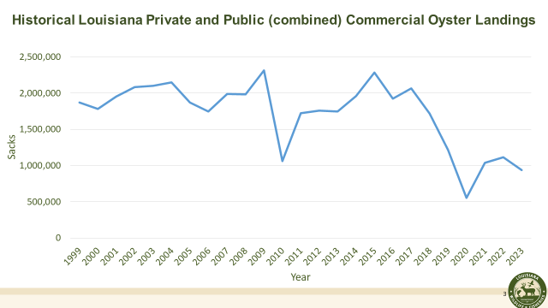

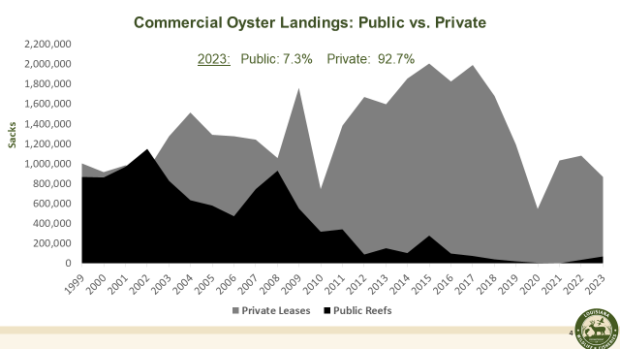

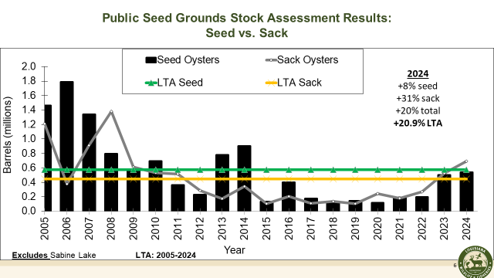

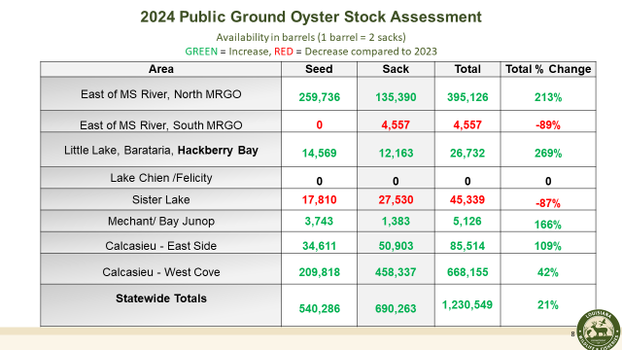

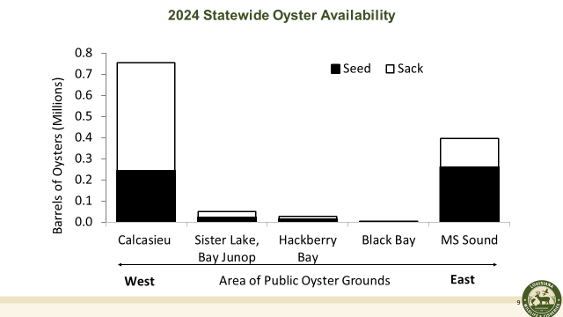

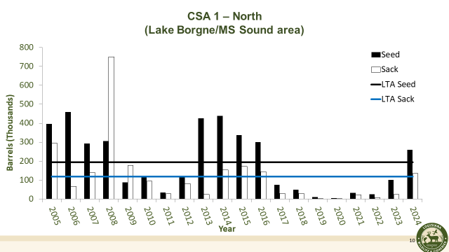

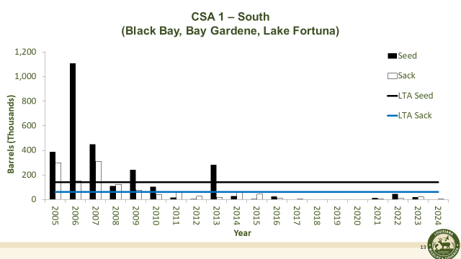

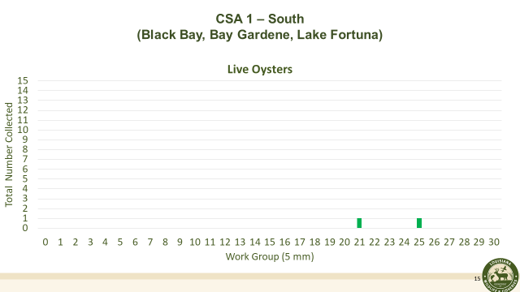 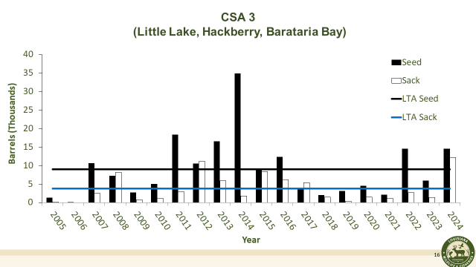 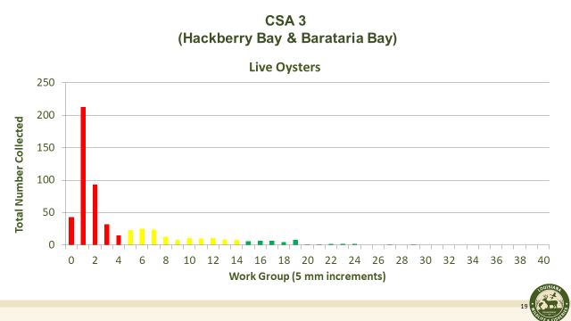 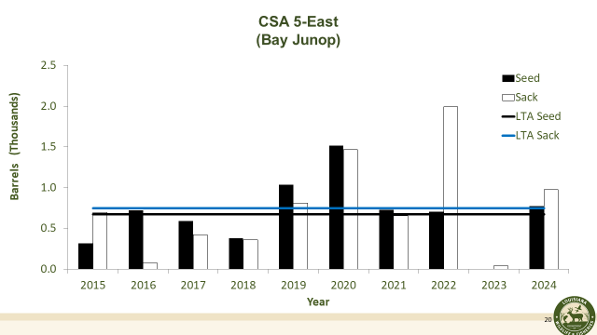

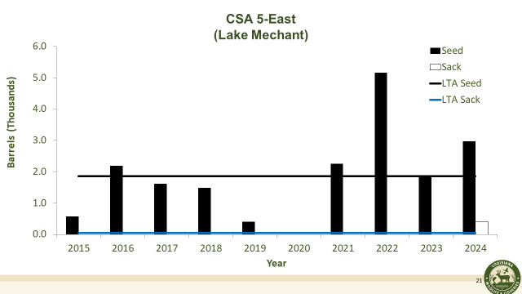

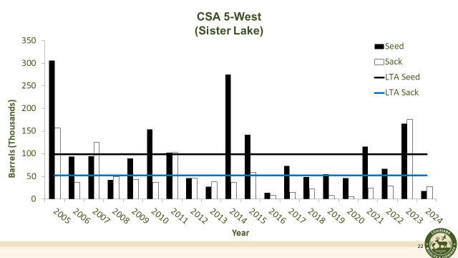

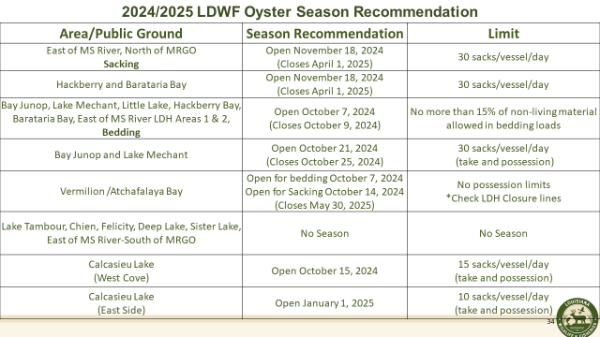

An instructional e-reporting video was shown to the board and can be found here: <https://www.wlf.louisiana.gov/page/oyster-e-reporting>

Jakov Jurisic requested a report on Deadman Islands and more information on Bay Eloi

Mitch Jurisich asked if there has been any discussion on moving up bedding times to mid-September to get more recruitment? Suggested around September 16th

Al Sunseri motioned to change bedding times to September 23rd, 2nd by Peter Vujnovich. Motion carries with one opposed, Jakov Jurisic.

Jakov Jurisic expressed concern with boats not being ready at this time, coolers need to be ready and prepared for the opening of the season, cannot in a moment’s notice offload their coolers and be ready

Robert Caballero concern with hot temperatures and it’s something to consider waiting until October for the cooler weather, Mitch Jurisich started that bedding was opened the Wednesday after Labor Day and the heat never really bothered the industry a whole lot

John Tesvich stated that between September 15 and October 15 is the prime time for bedding

Eric work out of Terrebonne Parish, public grounds concern with stealing oysters in Sister Lake get there late at night and gone with 30 sacks before sunrise, need more enforcement in the area, think some of the data is wrong because it does not take theft into account, LDWF recommended that if anyone sees or hears anything to contact Operation Game Thief to let them know about the issue

Al Sunseri motioned to accept the rest of LDWF’s recommendation with the amendment, 2nd by Peter Vujnovich. Peter withdrew 2nd

Jakov Jurisic expressed concern with the 15% non-living material, stated that this is way too restrictive and almost impossible to abide by, and impossible to enforce; Robert Caballero stated that it’s been in place since about 2017 and have not seen an issue with an uptick in enforcement issues with this

Al Sunseri stated that up until 2002 and 100 years before that it was 5% and before that it was 0%

John Tesvich stated that the 15% non-living material should be based on volume and not count and you will get a better measurement, maybe 20% by volume would be a lot easier

Al Sunseri stated that it would be good to determine a way to check what % of non-living material is in a load of oysters

Robert Caballero stated that the samples for non-living material are taken in one cubic box, go through and sort out and weigh reef material and determine % and then estimate this on 3 samples, have to have over 15% on all three samples to be considered over

Peter Vujnovich motioned to accept the rest of the LDWF’s oyster season recommendations, but add two amendments (1) would like to see an increase in the non-living material allowance from 15% to 30%, (2) Would like to see sacking areas open on November 1st  for East of MS River, North of MRGO and Hackberry/ Barataria areas 2nd by Brad Robin. Motion carries with 1 opposed, Al Sunseri

Al Sunseri stated that he believes 30% allowance of non-living material is too much of an allowance and do not think this is best for the resource or the reef

John Tesvich the date for opening the sacking areas November 18th, think it’s late, 3 weeks after Texas opens, November 1st would be a possible better date

**C.** Sandy Garcia provided a presentation on a proposal for a marketing campaign with WWLTV

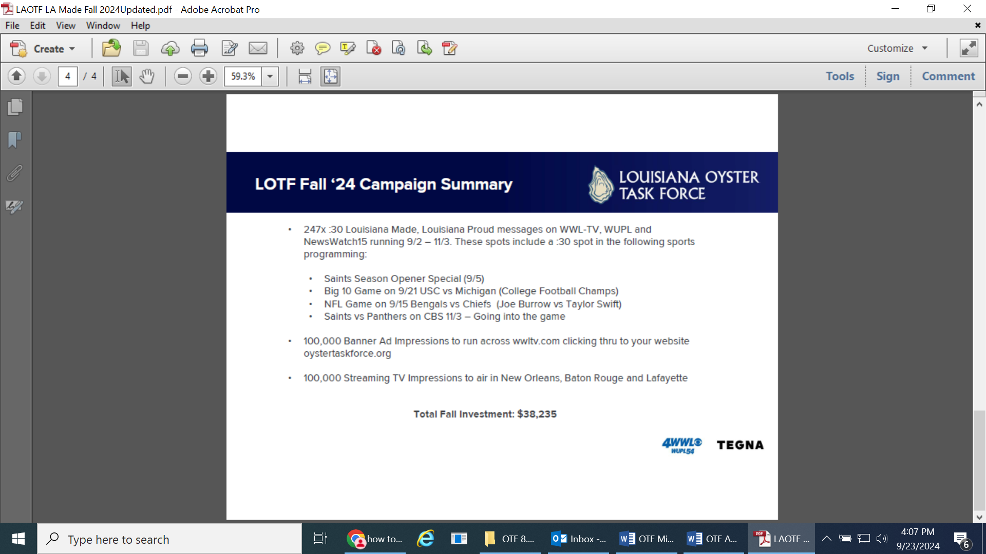

The task force request to get some more information on where LDWF is with getting the BA-7 budget adjustment

**D.** Sonya Williams provided an update on the 2019 Equipment Modernization Grant program

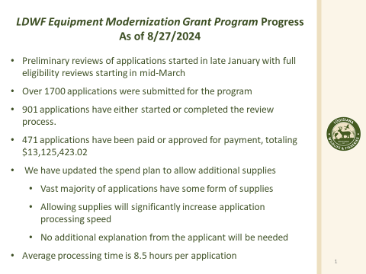

E. John Tesvich provided a proposal for changing oyster harvest time-temperature recording requirements on vessels and for dealers

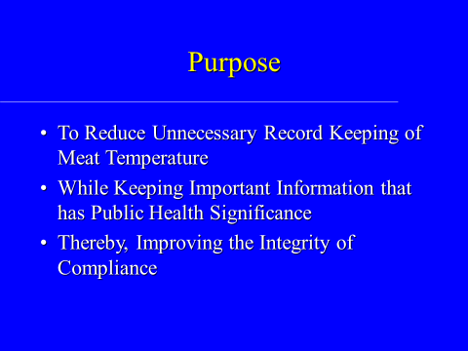

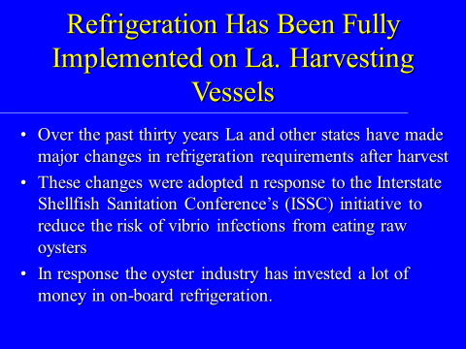

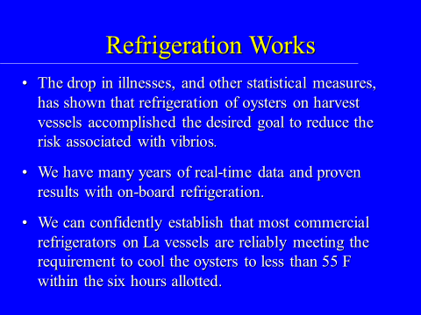

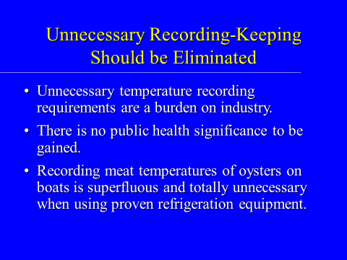

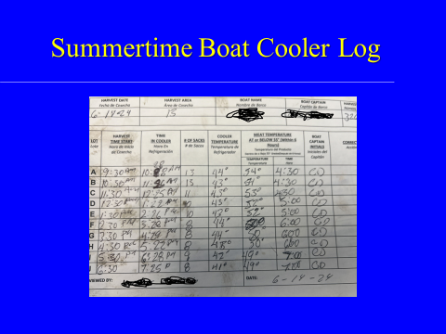

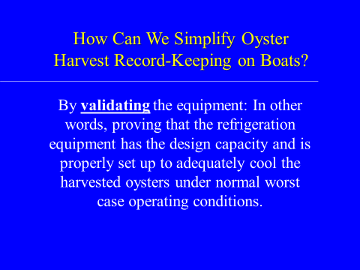

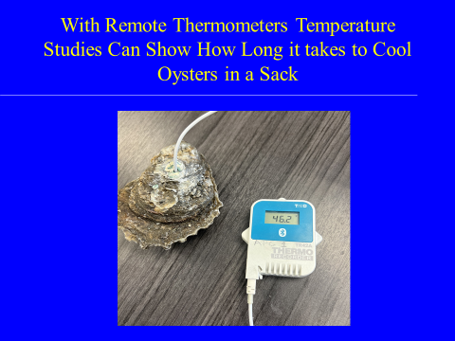

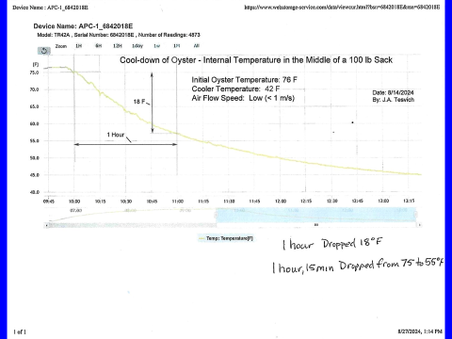 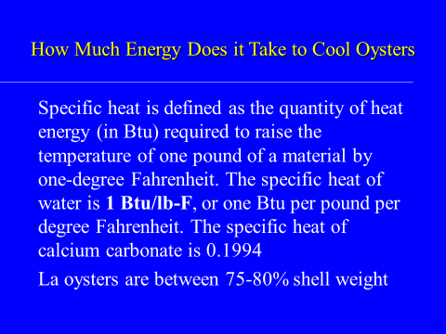

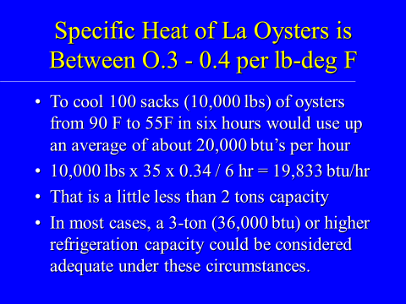

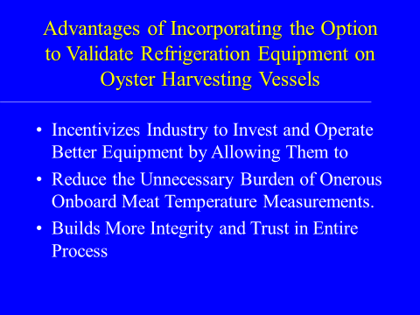

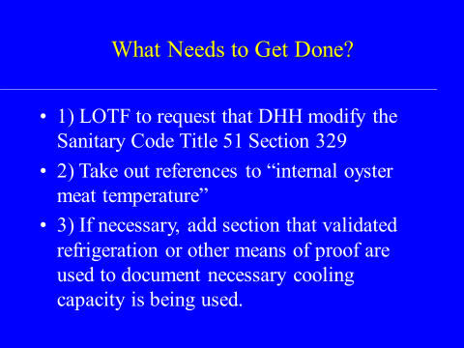

Al Sunseri suggested a meeting with LDH and FDA to present this information and request that these changes be made

Al Sunseri motioned that the task force representative from LDH and John Tesvich meet with the FDA, LDH, and ISSC to try to come up with language that would meet this methodology to reduce the required paperwork for testing internal oyster temperature, motion did not move forward as no second was made

John Tesvich suggested a 3 month verification that proves your equipment is working

Jen Armentor with LDH stated that this can be discussed and believes it probably can be addressed in individual HAACP plan, maybe conduct a validation study

The task force plans to host a Health Committee meeting prior to next full OTF meeting, asked Jen Armentor to look into options

**F.** The task force considered a draft resolution to support the continue work on Gulf hypoxia

Al Sunseri motioned to accept the resolution that was presented, 2nd by Peter Vujnovich. Motion carries.

**G.** The task force considered funding to renew the Beuerman Miller Fitzgerald PR contract

Brad Robin motioned to dedicate $50,000 to renew the Beuerman Miller Fitzgerald contract for another year, 2nd by Jakov Jurisic. Motion carries.

**H.** The task force considered funding for the Let the World Be Your Oyster Event

Al Sunseri motioned to give the chairman, Mitch Jurisich, the authority to approve funding for the Let the World Be Your Oyster Event as soon as BA-7 budget adjustment has been approved, 2nd by Brad Robin. Motion carries.

**I.** The board deferred discussion and consideration of funding for possible participation in the 2025 Super Bowl events

**VII.** Public Comment- no public comments

**VIII.** Next meeting set for Tuesday, October 1st for 10:00am at the New Orleans Lakefront Airport

**IX.** Brad Robin motioned to adjourn the meeting, 2nd by Peter Vujnovich. Motion carries.